Experiment 6: Parseval’s Relation and Harmonic Analysis
Objective 1: Verification of Parseval’s Relation for Periodic Signals
CODE :
clc; clear; close all;
figure;
f0 = 1;
T = 1/f0;
t = linspace(0,T,4000);
x= max(sin(2*pi*f0*t),0);
% Time-domain average power
P_time = (1/T)*trapz(t,abs(x).^2);
% Fourier-series coefficients
N = 20;
a0 = (2/T)*trapz(t,x);
an = zeros(1,N);
bn = zeros(1,N);
for k = 1:N
an(k) = (2/T)*trapz(t,x.*cos(2*pi*k*f0*t));
bn(k) = (2/T)*trapz(t,x.*sin(2*pi*k*f0*t));
end
% Frequency-domain power using Parseval's relation
P_freq = a0^2/4 + 0.5*sum(an.^2 + bn.^2)
fprintf('Time-domain power = %.6f\n',P_time);
fprintf('Frequency-domain power = %.6f\n',P_freq);
fprintf('Absolute error = %.6e\n',abs(P_time-P_freq));
bar([P_time P_freq]);
set(gca,'XTickLabel',{'Time Domain','Frequency Domain'});
ylabel('Average Power');
grid on;
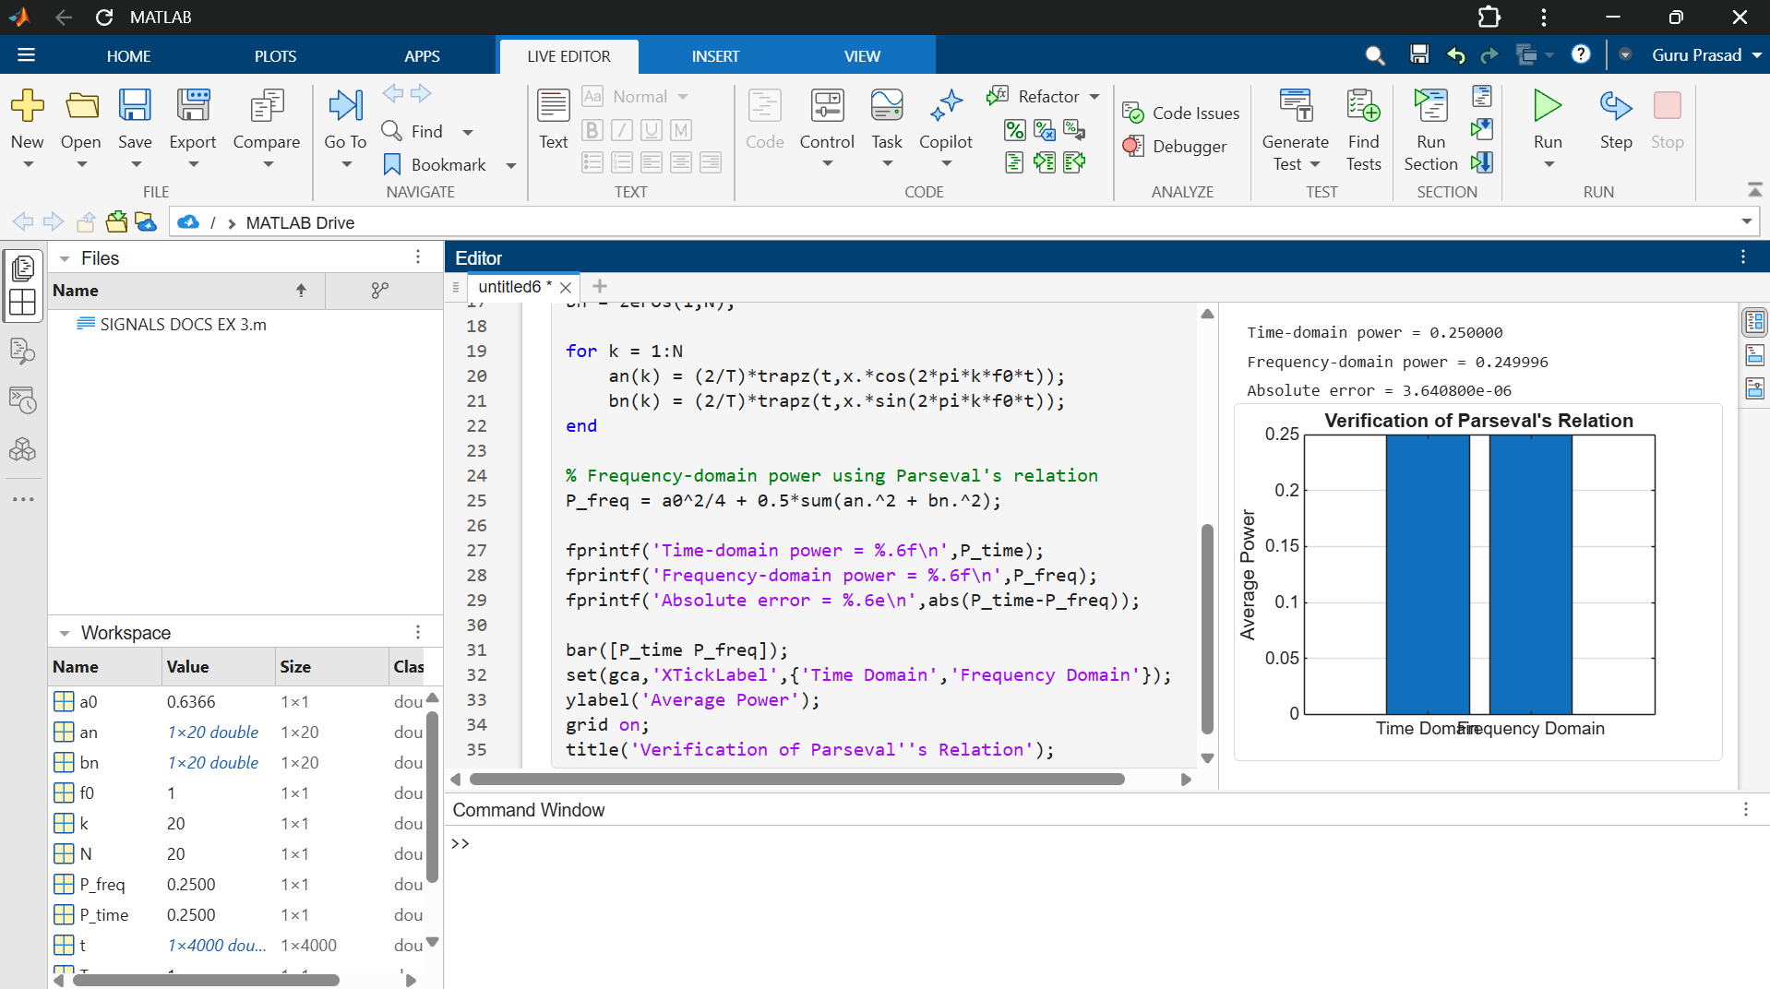
title('Verification of Parseval''s Relation');

Objective 2: Analysis of Energy and Power Distribution Among Harmonic Components

CODE :
clc; clear; close all;
figure;
f0 = 1;
T = 1/f0;
t = linspace(0,T,4000);
x = max(sin(2*pi*f0*t),0);
N = 20;
a0 = (2/T)*trapz(t,x);
an = zeros(1,N);
bn = zeros(1,N);
for k = 1:N
an(k) = (2/T)*trapz(t,x.*cos(2*pi*k*f0*t));
bn(k) = (2/T)*trapz(t,x.*sin(2*pi*k*f0*t));
end
P_h = 0.5*(an.^2 + bn.^2);
P_dc = a0^2/4;
bar(1:N,P_h);
grid on;
xlabel('Harmonic Number');
ylabel('Power Contribution');
title('Power Distribution among Harmonic Components');
fprintf('DC power contribution = %.6f\n',P_dc);

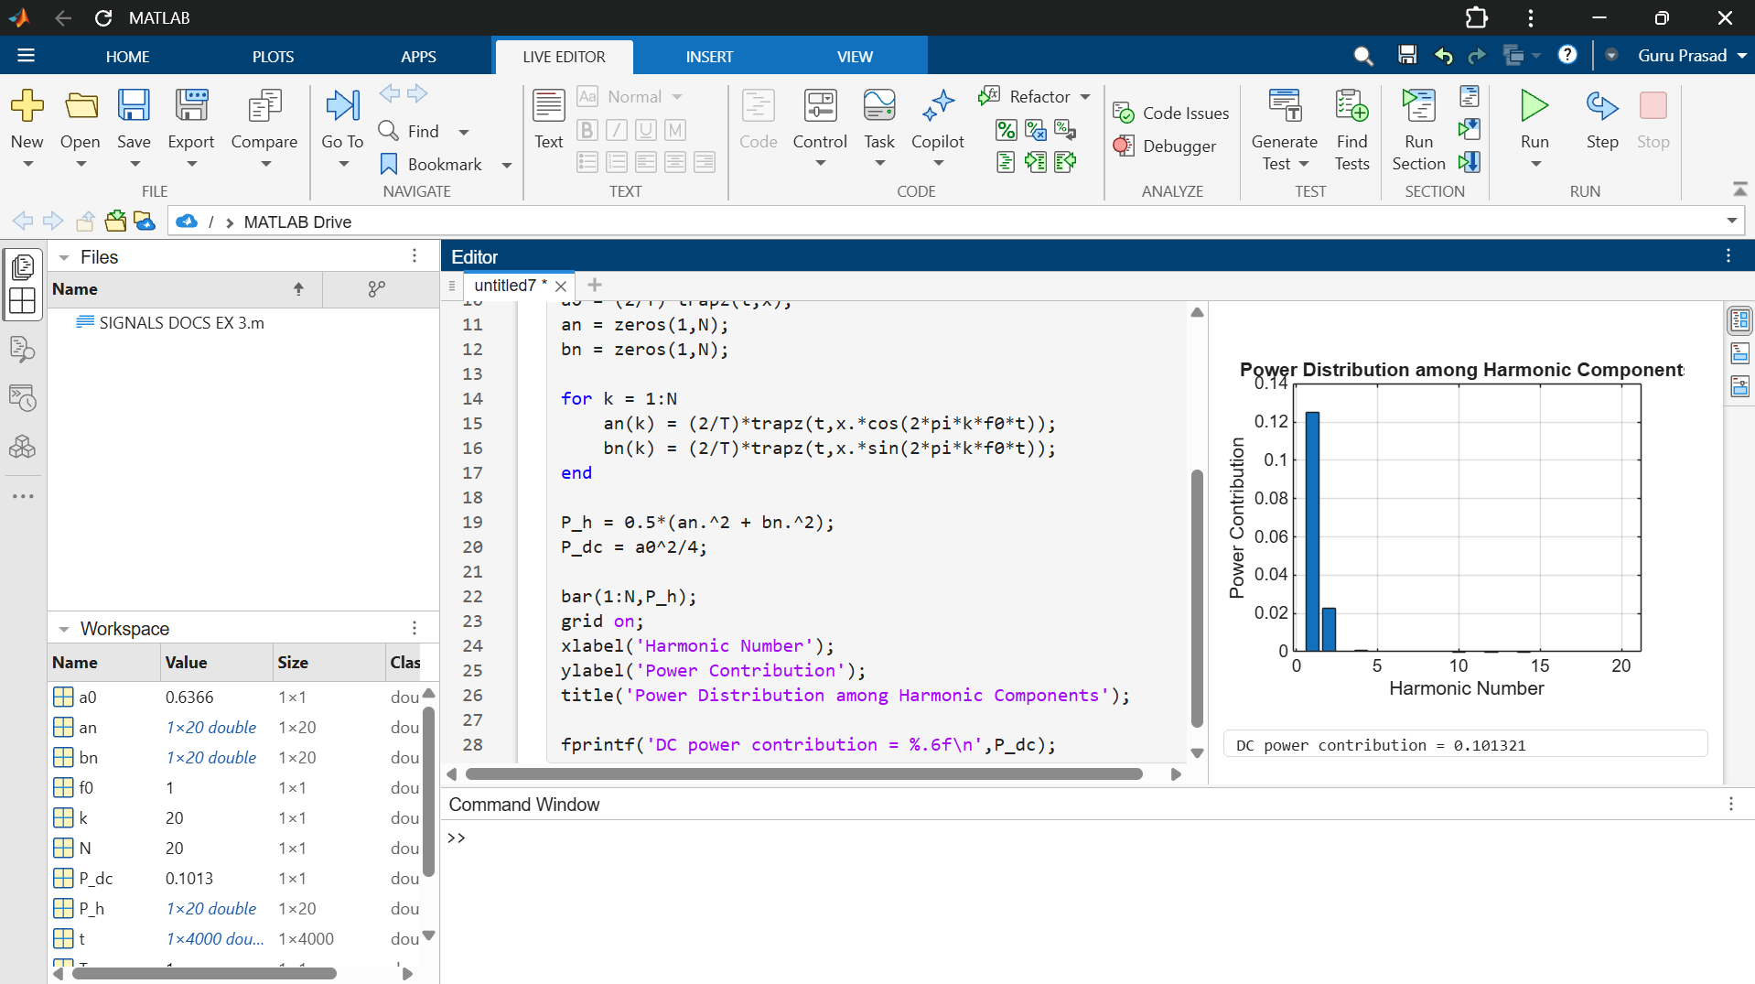
Objective 3: Determination and Analysis of Harmonic Spectrum
CODE :
clc; clear; close all;
figure;
f0 = 1;
T = 1/f0;
t = linspace(0,T,4000);
x = max(sin(2*pi*f0*t),0);
N = 15;
a0 = (2/T)*trapz(t,x);
an = zeros(1,N);
bn = zeros(1,N);
for k = 1:N
an(k) = (2/T)*trapz(t,x.*cos(2*pi*k*f0*t));
bn(k) = (2/T)*trapz(t,x.*sin(2*pi*k*f0*t));
end
H = sqrt(an.^2 + bn.^2);
f = (1:N)*f0;
stem(f,H,'filled');
grid on;
xlabel('Frequency (Hz)');
ylabel('Harmonic Magnitude');
title('Harmonic Spectrum of Periodic Signal');

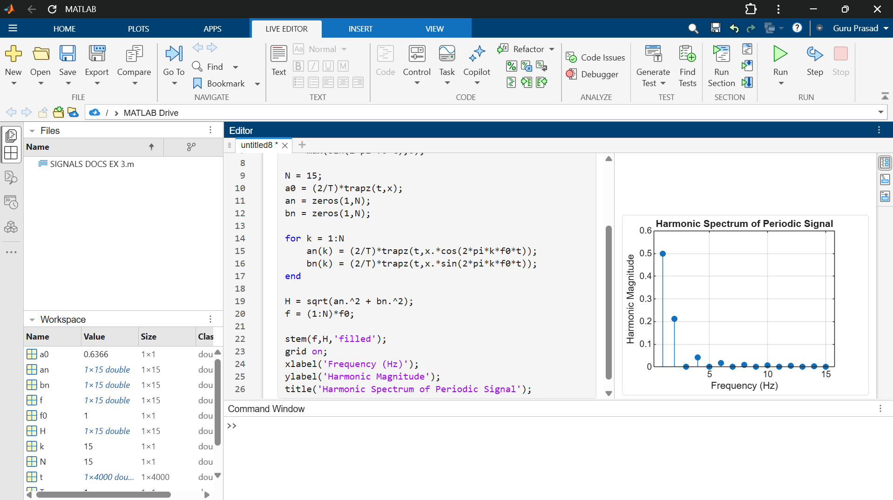

Objective 4: Comparison of Time-Domain Power with Frequency-Domain Harmonic Power
CODE:
clc; clear; close all;
figure;
f0 = 1;
T = 1/f0;
t = linspace(0,T,4000);
x = max(sin(2*pi*f0*t),0);
P_time = (1/T)*trapz(t,x.^2);
N = 20;
a0 = (2/T)*trapz(t,x);
an = zeros(1,N);
bn = zeros(1,N);
for k = 1:N
an(k) = (2/T)*trapz(t,x.*cos(2*pi*k*f0*t));
bn(k) = (2/T)*trapz(t,x.*sin(2*pi*k*f0*t));
end
P_dc = a0^2/4;
P_harmonics = 0.5*sum(an.^2 + bn.^2);
P_frequency = P_dc + P_harmonics;
fprintf('Time-domain power = %.6f\n',P_time);
fprintf('DC power = %.6f\n',P_dc);
fprintf('Harmonic power = %.6f\n',P_harmonics);
fprintf('Frequency-domain power = %.6f\n',P_frequency);
bar([P_time P_frequency]);
set(gca,'XTickLabel',{'Time Domain','Frequency Domain'});
ylabel('Average Power');
grid on;
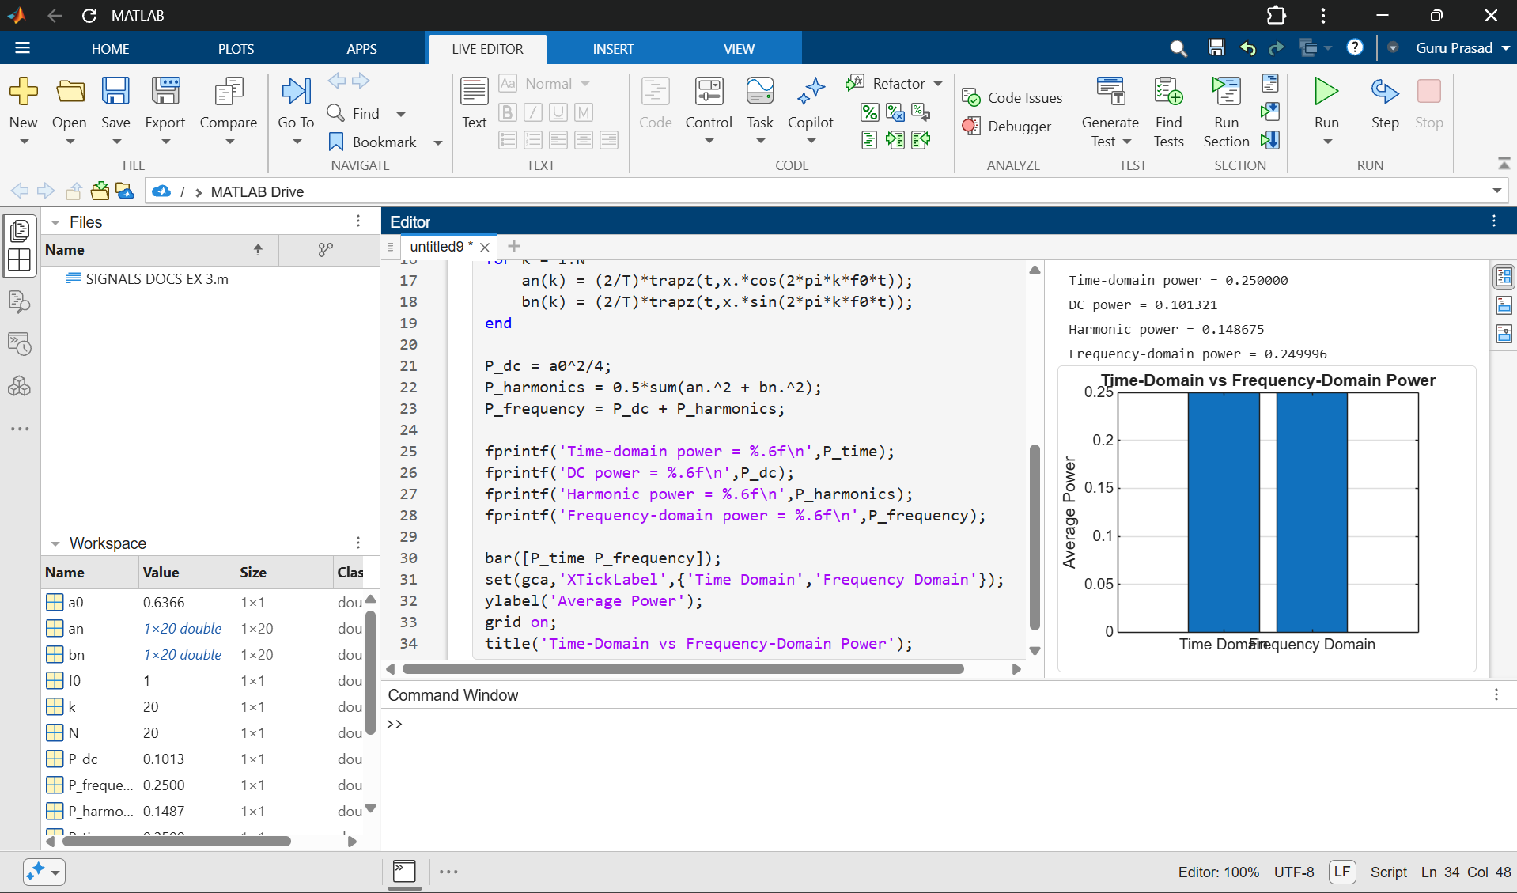
title('Time-Domain vs Frequency-Domain Power');

